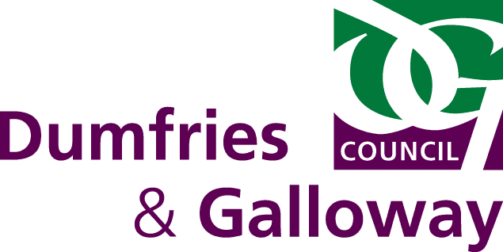

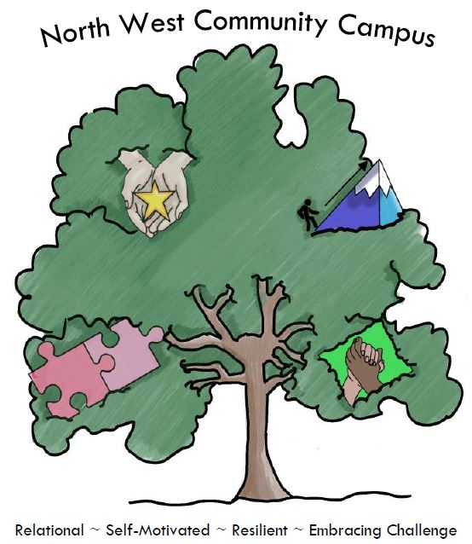

Education and Learning Directorate

School/ELC Annual School Improvement Planning

2025-2026

School: North West Community Campus (Primary)

Date: May 2025
SCHOOL IMPROVEMENT PLAN 2025 – 2026 (Limit the number of priorities to ensure they are manageable and achievable.)

School Priority  /Improvement Area for Learners |  | Review our approaches to inclusion.
Evidence to support decision to prioritise this area (include baseline measures) |  | Outcomes for Learners/School Community |  | Key Tasks
Self-evaluation against CIRCLE Framework – completed March 2025  Staff identified the following barriers/challenges:  Accessibility of space  Adequacy of space  Sensory space  Availability of objects  Rules and boundaries |  | All stakeholders promote a climate where children and young people feel safe and secure.  Staff and partners will create an environment where children and young people feel listened to and are secure in their ability to discuss personal and sensitive aspects of their lives because they feel cared about.  All staff and partners will take due account of the legislative framework related to wellbeing, equality and inclusion.  All staff will engage in regular professional learning to ensure they are fully up-to-date with local, national and, where appropriate, international legislation affecting the rights, wellbeing and inclusion of all children and young people.  Children and young people are knowledgeable about equalities and inclusion. |  | All staff (teaching and non-teaching) to complete 2 hour Inclusive Practice training with L Henderson (PT).  Next steps to be identified following self-evaluation against CIRCLE framework – identify short, medium and long term priority areas.  Look outwards at D&G schools who model good practice.  Utilise D&G Building Capacity papers and local inspection reports.  Seek external support based on whole staff professional learning needs. For example, Primary Inclusion, Educational Psychology, Speech and Language, Autism Outreach and Attendance Support)  Revisit CIRCLE framework self-evaluation as a follow-up assessment.  Consultation/evaluation with pupils and families.  Planned collegiate focus on D&Gs Framework for Inclusion.
NIF Priority |  | NIF Driver |  | HGIOS?4 / HGIOELC QIs/National Standard Criteria
Placing the human rights and needs of every child and young person at the centre of education  Improvement in children and young people's health and wellbeing |  | Teacher professionalism  School improvement  School leadership  Assessment of children’s progress  Performance information  Parent/carer involvement and engagement |  | HGIOS4 QI 3.1/2.7/1.1/1.3
Responsible/Lead Person | Time Allocations |  | Funding – including PEF |  | Expected Completion Date
B Maxwell-Grierson (HT)  J McKinnell (DHT)  A Dalton (IP Lead) | Through WTA |  | PEF – targeted support to children |  | June 2026
Parental and Learner Engagement Opportunities |  |  | Linkage to Framework for Inclusion
Consultation/evaluation with learners and families.  Sharing good practice with families. |  |  | Wellbeing  Inclusive community  Relationships & Rights  Policy & procedure

School Priority  /Improvement Area for Learners |  | Develop a progressive Health & Wellbeing Curriculum.
Evidence to support decision to prioritise this area (include baseline measures) |  | Outcomes for Learners/School Community |  | Key Tasks
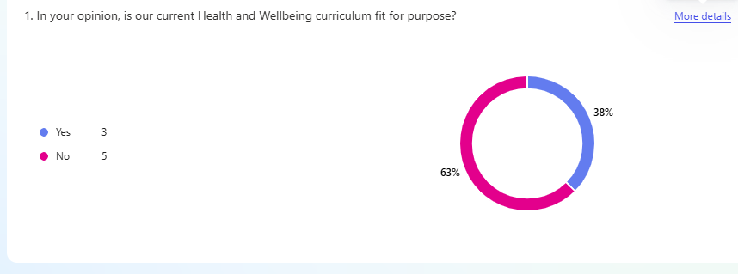  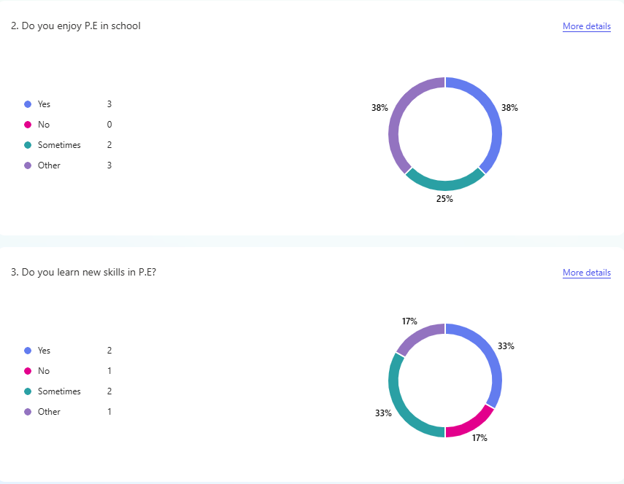  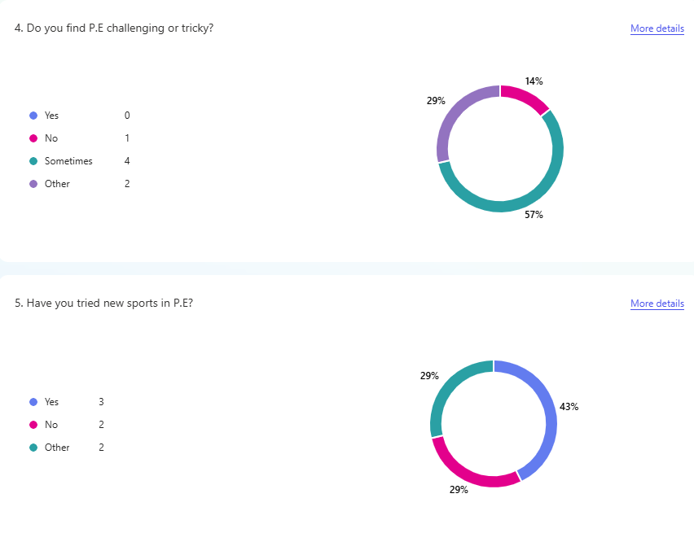  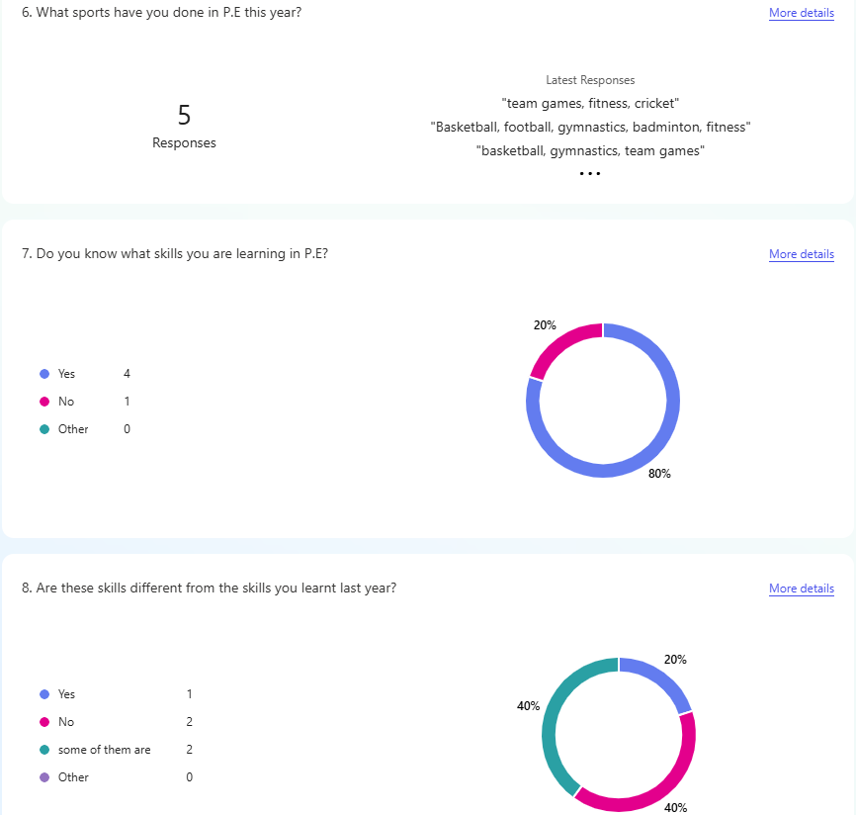 |  | Our Health and Wellbeing Curriculum will support progressive pathways from pre-early to second level.  The whole learning community will have a shared understanding of wellbeing and the children’s rights.  The curriculum will provide children and young people with well-planned and progressive opportunities to explore diversity and multi-faith issues, and to challenge racism and religious intolerance.  Our curriculum will have a strong focus on developing the skills our young people need in the world of work |  | Creation of individual planners to support progressive coverage.  Creation of a whole school overview to support Health & Wellbeing.  Continue to develop Gold UNCRC Action Plan.  Review of HWB assessments.  Implement HWB tracking.  Identify alternative learning pathways.  DYW lead identified.  DYW lead to explore opportunities to develop skills for work.  Introduce My World of Work from P5-P7.
NIF Priority |  | NIF Driver |  | HGIOS?4 / HGIOELC QIs/National Standard Criteria
Placing the human rights and needs of every child and young person at the centre of education  Improvement in children and young people's health and wellbeing  Improvement in skills and sustained, positive school-leaver destinations for all young people |  | Teacher professionalism  School improvement  School leadership  Assessment of children’s progress  Performance information |  | HGIOS4 QI 1.1/1.3/2.2/2.3/2.4/3.1/3.3
Responsible/Lead Person | Time Allocations |  | Funding – including PEF |  | Expected Completion Date
B Maxwell-Grierson (HT)  C Kirkpatrick (PT)  D Malin (PT) | Through WTA  Voluntary staff working group |  | N/A |  | Review progress June 2026
Parental and Learner Engagement Opportunities |  |  | Linkage to Framework for Inclusion
Pupil consultation.  Sharing good practice – UNCRC.  Pupil assemblies – UNCRC.  Family learning – HWB focus |  |  | Wellbeing  Inclusive community  Relationships & Rights

